The Object Dictionary Concept
The core of any CANopen node is the Object Dictionary, a lookup table with a 16-bit index and an 8-bit sub-index. This allows for up to 255 sub-entries at each index. Each entry can be variable in type and length.
All process and communication related information/data is stored as entries in pre-defined locations of the object dictionary. Unused entries do not need to be implemented.
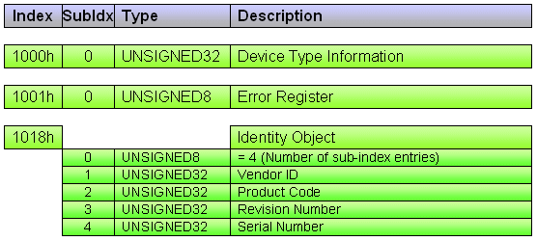
Figure 1 Mandatory Object Dictionary Entries
From the network, object dictionary data of any node can be accessed in a point-to-point communication mode by issuing read or write requests to the node's object dictionary. Messages that contain requests or answers to/from the object dictionary are called Service Data Objects (SDO). As both process and configuration data are part of the object dictionary, this communication scheme immediately allows for configuring nodes and/or getting access to the process data.
The default scenario is, that any node has two CAN identifiers reserved for SDO requests to and SDO replies from the object dictionary. The default CAN ID for the Receive Service Data Object (RSDO - used to send requests to a node) is a base address of 600h plus the node ID number. The ID for the Transmit Service Data Object (TSDO - used by a node to reply to requests) is a base address of 580h plus the node ID number. In this scenario, RSDOs may only be used by one node (usually the master, sometimes a configuration tool), to avoid conflicts/collisions arising from multiple nodes potentially trying to access a specific object dictionary at the same time.
The master or configuration tool can now scan for connected devices by sending 127 RSDO requests for the identity object - one to each potential node. All nodes present will respond with their TSDO containing the identification data from their object dictionary.

Device Profiles
Although the object dictionary concept allows for structuring the data that needs to be communicated, there is still something missing: Which entry in the dictionary is used for what? The dictionary is far too big that we could allow the master to take "wild guesses" and simply try to access certain areas of the dictionary to see if they are supported.
The solution is simple: First of all, there are a few mandatory entries that all CANopen nodes must support. These include the identity object with which a node can identify itself and an error object to report a potential error state. Additional entries are specified by device profiles. Device profiles describe all the communication parameters and object dictionary entries that are supported by a certain type of CANopen modules. Such profiles are available for generic I/O modules, encoders and other devices.
A master or configuration tool can read-access the identity object of any slave node using a SDO. As a reply, it receives a SDO with the information about which device profile a module conforms to. Assuming the master knows which object entries are defined for a particular device profile, it now knows which object dictionary entries are supported and can access them directly.
CANopen is open! If an application requires the implementation of non-standardized, manufacturer specific object dictionary entries, then that is not a problem. Adding entries that disable/enable a certain functionality that is not covered by one of the existing device profiles can be implemented to any device, as long as they conform to the structural layout of the object dictionary.

